# AM000-Asia-Japan-Edo-Four Animals-Eighteen Clouds

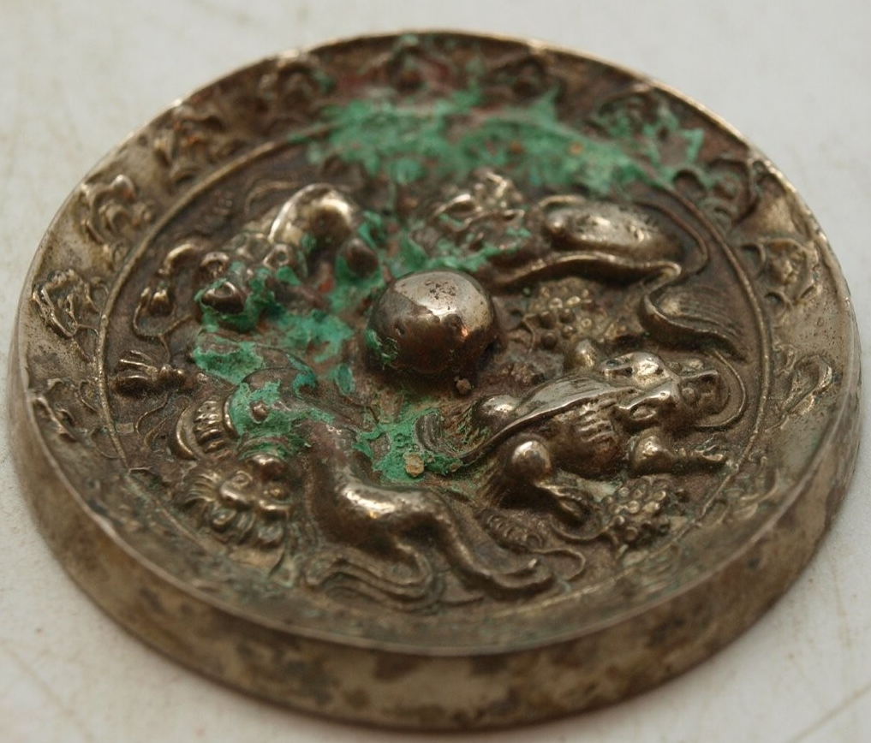

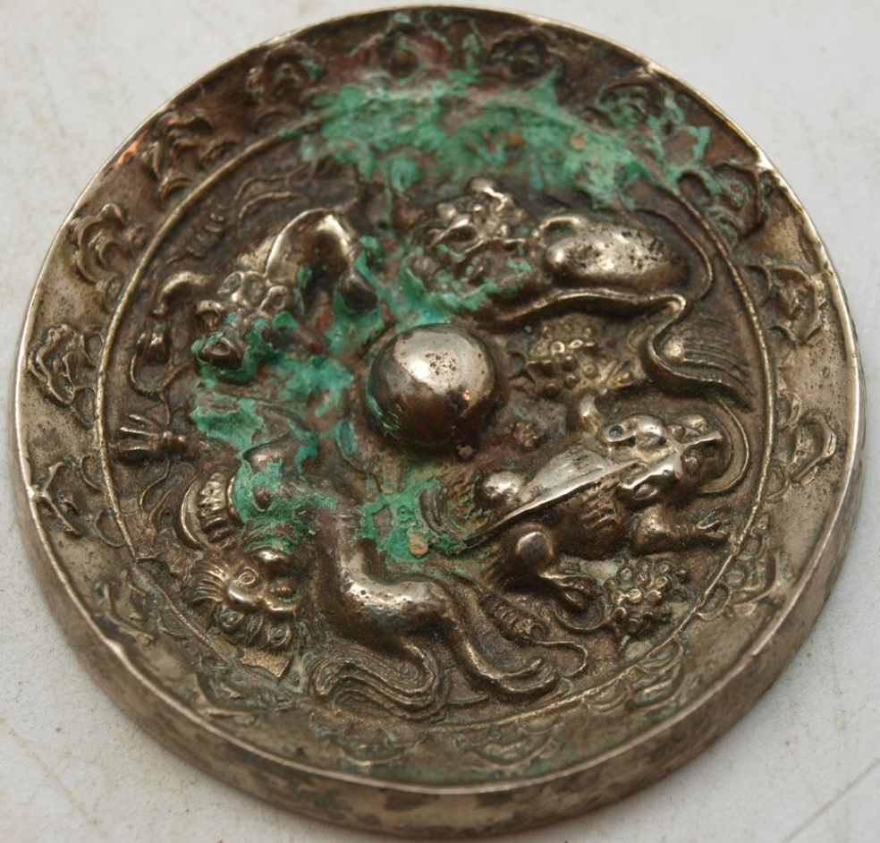

# 

# Round Oriental Bronze Mirror - Chinese Mythical Creatures - Silver Plated - 52mm

Stunning bronze Japanese mirror measuring 52mm in diameter.  This bronze mirror is silver plated, but has been heavily tarnished.  The back is decorated with primitive scenes of oriental mythical creatures.  It has a central boss which is pierced to allow a cord to be passed through for holding.  The other side is undecorated and would have originally been polished to create a reflective surface.

Bronze mirrors were introduced into Japan from China and Korea during the Yayoi period (about 300 BC - AD 300). At first they had a religious function and were regarded as symbols of authority. The Japanese soon learnt to make their own mirrors using the lost-wax technique, decorating them with Chinese or native Japanese designs.

By the Nara period (AD 710 -794) mirrors were being made for everyday use, with the increasing use of Japanese designs, such as native plants and animals symbolising good fortune. From the Kamakura period (1185-1333) a design showing Horaizan (the Chinese 'Island of Immortality') became popular.

Mirrors gradually became more robust. They mostly have a central boss, often in the shape of a tortoise, which was pierced and a cord passed through for holding. More new designs and the first handled mirrors appeared in the Muromachi period (1333-1568).

During the Edo period (1600-1868), mirrors decorated with lucky symbols or Chinese characters were given at weddings. Mirrors became larger as hairstyles became more ornate; some mirrors in Kabuki theatre dressing-rooms were up to fifty centimetres across and were placed on stands. The faces of mirrors were highly polished or burnished, with itinerant tinners and polishers specializing in this work.

Since the mirror, together with the sword and the jewel, were symbols of Imperial power, mirror-makers were deeply revered and often given honorary titles such as Tenka-Ichi ('First under Heaven'). However, this title was often misused and was officially prohibited in 1682.

Bronze mirrors were replaced by glass mirrors after the Meiji Restoration (1868).

Bought recently as part of a small private collection of oriental bronzes.

